Adam Gincel

CS 135

Professor Engling

*I pledge my honor I have abided by the Stevens Honor System.*

Homework 8

1.

A: Yes

B: Yes

C: Yes

21. No

22. Yes

23: No

35.

A: [2]5 = {…-8, -3, 2, 7, 12, 17…}

B: [3]5 = {…-7, -2, 3, 8, 13, 18…}

D: [-3]5 = {…-8, -3, 2, 7, 12…}

44.

B: The set of positive integers is a partition of all integers, as is the set of negative integers. 0 could be considered an “unsigned” integer, being in neither set. They do not union to make the whole set of integers.

C: i mod 3 = 0, i mod 3 = 1, and i mod 3 = 2 are all unique partitions of the set of integers.

58.

A. Because we are rotating and reflecting these same three beads, we know the relation R is symmetric. Because you can have the same color beads on a bracelet, the relation is reflexive, and because we can make any combination, the relation is transitive. Therefore, the relation is an equivalence relation.

B:

(R, R, R)

(W, W, W)

(B, B, B)

(R, R, W) (R, W, R) (W, R, R)

(R, W, W) (W, R, W) (W, W, R)

(R, R, B) (R, B, R) (B, R, R)

(R, B, B) (B, R, B) (B, B, R)

(B, B, W) (B, W, B) (W, B, B)

(W, W, B) (W, B, W) (B, W, W)

(R, W, B) (W, B, R) (B, R, W) (R, B, W) (W, R, B) (B, W, R)

9.6

2.

B: Not partial ordering

C: Not partial ordering.

9: No

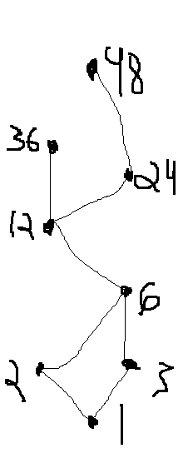10: Yes

23. C:

67.

Determine User Needs

Write Functional Requirements

Set up test sites

Develop System Requirements

Write Documentation

Develop Module A, B, then C

Integrate Modules

Test

Test with test sites

Completion